Jining Donghong Machinery Co., Ltd
Oilfield equipment and spare parts supplier of China
Dedicate to Petroleum E&P Business,Strive to Be a World-class Service Provider

We supply spare parts and equipment of truck-mounted drilling rig,trailer-mounted drilling rig, work over rig ,electrical drilling rig etc. Keep long business cooperation relationship with API Manufacturers BOMCO,LSNOW,SICHUANG HONGHUA,SJ PETRO,RG PETRO, BPMF, GGPMF, RONGSHENG,SHENKAI,BEIJING PSK, RENQIU BOKE,HYSUN MARINE etc.

Contact us
www.dhparts.com
Spareparts1960@foxmail.com
dh@dhparts.com
SKYPE:spareparts1960
Mobile/WhatsApp:0086-189-5407-9939

WJQ5×6J Shearing Pump
Model | Flow-line (m³/h) | Head(m) | Speed (r/min) | Efficiency (%) | NPSH (m) | Power (kW)
 |  |  |  |  |  | Shaft power | Equipped power
WJQ5×6J-75kW | 150 | 30 | 2150 | 28 | 3 | 46 | 75
WJQ5×6J-55kW | 140 | 26 | 2050 | 28 | 3 | 35 | 55
WJQ5×6J-45kW | 105 | 24 | 1750 | 28 | 2.8 | 25 | 45
WJQ5×6J-37kW | 105 | 24 | 1750 | 28 | 2.8 | 25 | 37

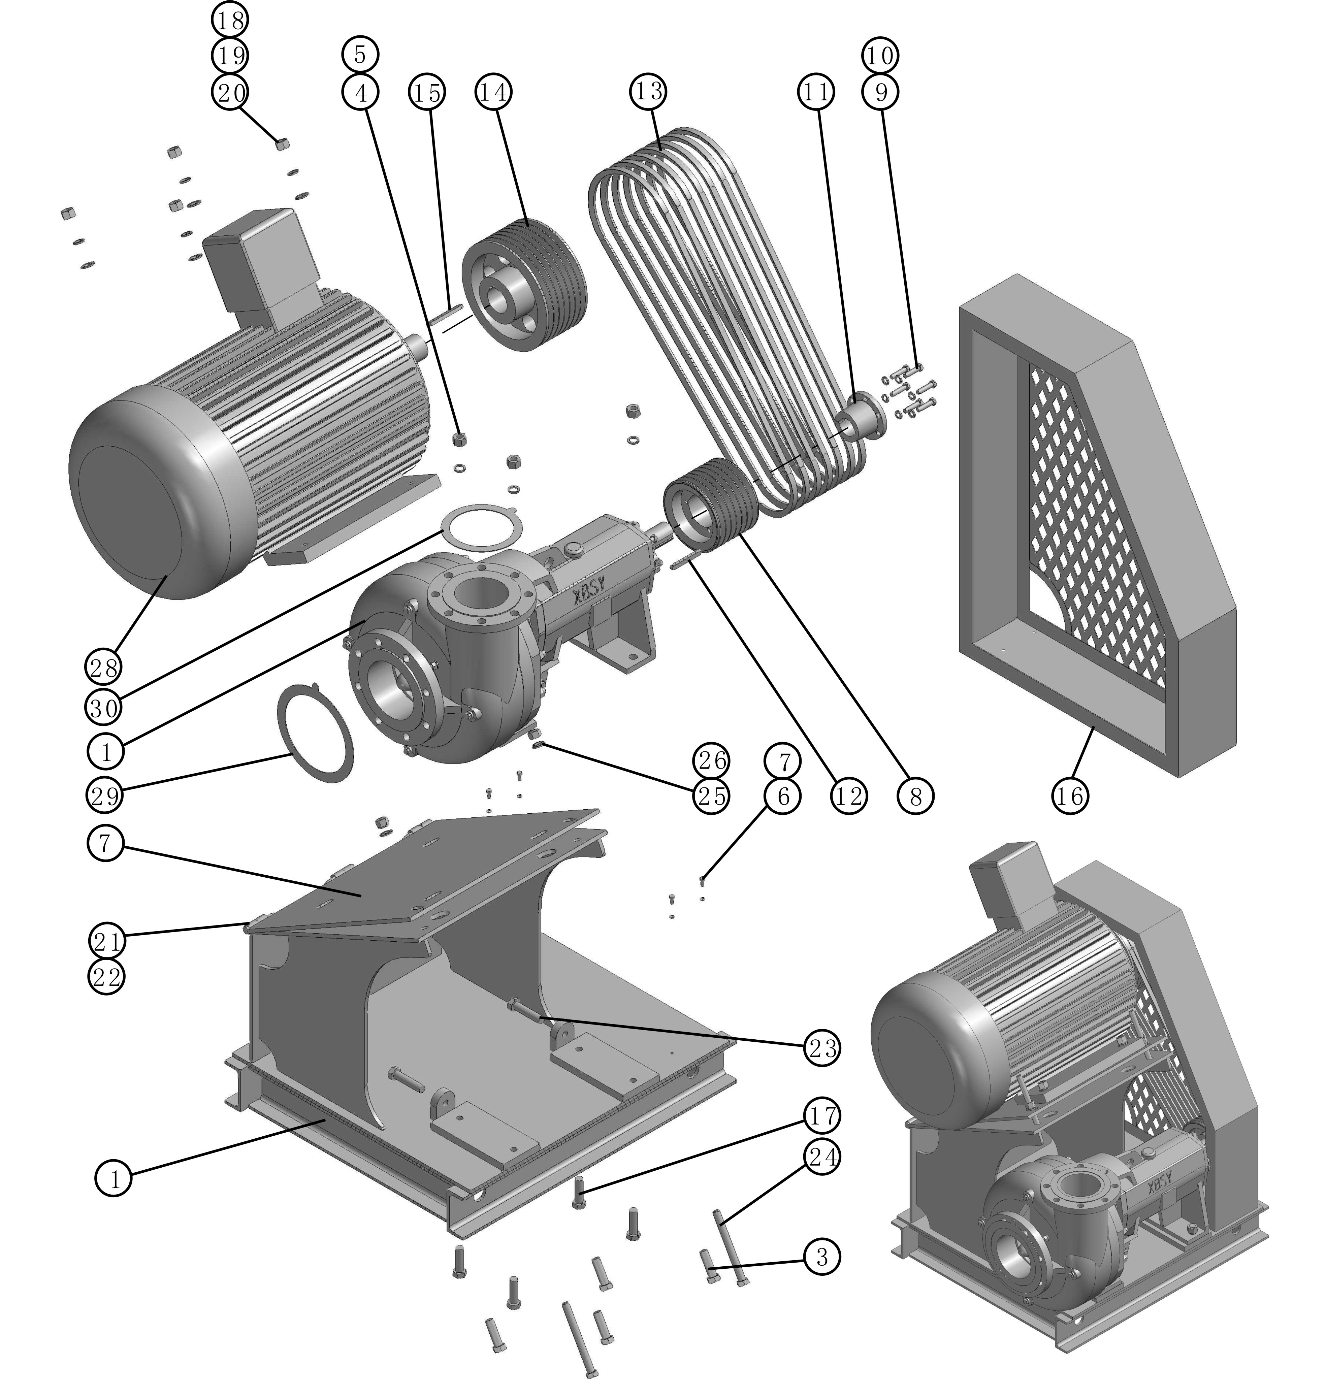

No. | Part Name | Part No. | Qty | No. | Part Name | Part No. | Qty
1 | Pump case | WJQ56J0001S | 1 | 16 | Shield | WJQ56J0016S | 1
2 | Base | WJQ56J0002S | 1 | 17 | Bolt | WJQ56J0017S | 4
3 | Bolt | WJQ56J0003S | 4 | 18 | Nut | WJQ56J0018S | 4
4 | Nut | WJQ56J0004S | 4 | 19 | Washer | WJQ56J0019S | 4
5 | Washer | WJQ56J0005S | 4 | 20 | Flat washer | WJQ56J0020S | 4
6 | Bolt | WJQ56J0006S | 4 | 21 | Pin | WJQ56J0021S | 3
7 | Nut | WJQ56J0007S | 4 | 22 | Split pin | WJQ56J0022S | 3
8 | V-Belt wheel | WJQ56J0008S | 1 | 23 | Bolt | WJQ56J0023S | 2
9 | Bolt | WJQ56J0009S | 3 | 24 | Bolt | WJQ56J0024S | 2
10 | Washer | WJQ56J0010S | 3 | 25 | Nut | WJQ56J0025S | 8
11 | Sleeve | WJQ56J0011S | 1 | 26 | Washer | WJQ56J0026S | 4
12 | Flat key | WJQ56J0012S | 1 | 27 | Base of Motor | WJQ56J0027S | 1
13 | V-belt | WJQ56J0013S | 4 | 28 | Motor | WJQ56J0028S | 1
14 | Motor wheel | WJQ56J0014S | 1 | 29 | Inlet spacer | WJQ56J0029S | 1
15 | Flat key | WJQ56J0015S | 1 | 30 | Outlet spacer | WJQ56J0030S | 1

