Keywords:Pneumatic motor pressure control valve,JYSM21-40
Beijing BPM,Beijing Petroleum Machinery Co.,Control System for Surface Mounted BOP Stacks, bop control unit, koomey unit, BPMF BOP CONTROL, accumulator unit, FKDQ1200-9,FKDQ1200-9B,FKDQ960-7,FKDQ640-7,FKQ1440-14,FKQ1200-9,FKQ1280-8,FKQ960-8,FKQ840-8,FKQ800-8,FKQ1280-7,FKQ1200-7,FKQ800-7D,FKQ800-7E,FKQ800-7F,FKQ800-8G,FKQ800-9H,FKQ640-7,FKQ800-6FFKQ720-6,FKQ640-6G,FKQ640-6,FKQ640-6M,FKQ640-6S,FKQ480-5,FKQ480-5C,FKQ480-5E,FKQ480-5B,FKQ480-5D,FKQ320-4B,FKQ3204E,FKQ320-4G,FKQ320-3,FKQ160-4W,FK250-4,FK240-4,FK160-4,FK100-4,FK240-3E,FKQ240-3D,FK240-3,FK125-3,FK125-3B,FK125-2D,FK125-2F,FK50-1

Product name:Pneumatic motor pressure control valve
Model:JYSM21-40
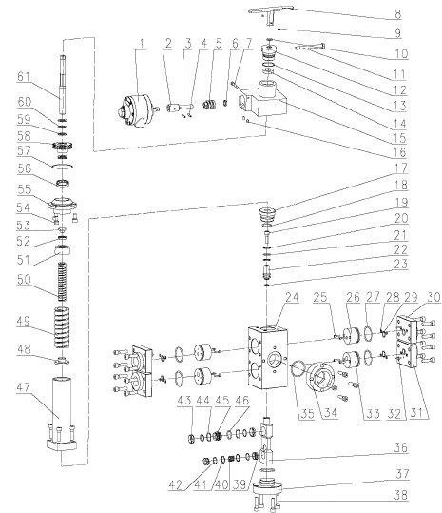
1 Pneumatic motor head 5126990461 1
2 Adaptor sleeve 9165100011 1
3 Elastic cylinder pin 4207010400 1 5×25 GB/T879.1-2000
4 Elastic cylinder pin 4207010410 1 5×20 GB/T879.1-2000
5 Worm screw 9165100009 1
6 Deep ball bearing 4301001370 1 21×12×5 61801
7 Superposed valve screw 4201990060 1 M6×50
8 Handle body 9165101000 1
9 Hidden hex-conic end screw 4201030350 2 M6×6 GB/T78-2000
10 O-ring 5303101120 1 15×2.65 GB/T3452.1-1992
11 Lock handle 9165100007 1
12 Lock cap 9165700025 1
13 O-ring 5303101110 1 36.5×1.8 GB/T3452.1-1992
14 Hexwasher 9165100006 1
15 Valve body 9165700022 1
16 Hidden hex-conic end screw 4201030360 2 M8×12 GB/T78-2000
17 Guide sleeve 9165700015 1
18 O-ring 5303001240 2 43.7×3.55 GB/T3452.1-1992
19 Hidden hex screw 4201120240 1 M10×30 GB/T70.1-2000
20 Retaining ring 9165700009 2
21 O-ring 5303001050 1 20×2.65 GB/T3452.1-1992
22 Sealing plug 9165700016 1
23 O-ring 5303001570 1 12.5×1.8 GB/T3452.1-1992
24 Valve body 9165700010 1
25 Hidden hex screw 4201120780 8 M4×30 GB/T70.1-2000
26 Oil return plunger 9165700012 2
27 O-ring 5303001250 4 47.5×3.55 GB/T3452.1-1992
28 O-ring 5303000030 8 6×1.8 GB/T3452.1-1992
29 O-ring 5303001540 4 18×1.8 GB/T3452.1-1992
30 Oil return flange 9165700003 1
31 Oil inducing and return flange 9165700011 3
32 Elastic cylinder pin 4207010430 4 4×16 GB/T879.1-2000
33 Oil inducing plunger 9165700008 2
34 Delivery flange 9165700023 1
35 O-ring 5303000180 1 50×3.55 GB/T3452.3-1988
36 Seal box 9165700013 1
37 Lower plug 9165700007 1
38 Hidden hex screw 4201120260 28 M10×40 GB/T70.1-2000
39 Relief sealing ring 9165700005 2
40 Spring 9165700006 1
41 Retaining ring 9165700014
42 O-ring 5303001550 4 21.2×1.8 GB/T3452.1-1992
43 Oil drain sealing ring 9165700001 2
44 Wavy spring 9165700004 2
45 Oil drain sealing spacer 9165700002 1
46 O-ring 5303001560 1 25.8×2.65
47 Spring base 9165701000 1
48 Spring under bracket 9165700017 1
49 Big spring 9165700018 1
50 Little spring 9165700019 1
51 Spring upper bracket 9165700020 1
52 Bearing 4301000060 1 51102 GB301-1995
53 Bearing cover 9161200014 1
54 Hidden hex screw 4201120210 3 M10×20 GB/T70.1-2000
55 Bearing pedestal 9165100001 1
56 Roller bearing 4301001350 1 48×38×13 BA-248Z
57 O-ring 5303110060 1 69.57×1.78 AS568－039
58 Worm wheel 9165100002 1
59 Bearing shim 9165100003 4
60 Cylindrical roller bearing 4301001360 2 35×20×2 889104
61 Core shaft 9165700021 1

