Keywords:Pneumatic motor pressure control valve,JYSM21-25,
Beijing BPM,Beijing Petroleum Machinery Co.,Control System for Surface Mounted BOP Stacks, bop control unit, koomey unit, BPMF BOP CONTROL, accumulator unit, FKDQ1200-9,FKDQ1200-9B,FKDQ960-7,FKDQ640-7,FKQ1440-14,FKQ1200-9,FKQ1280-8,FKQ960-8,FKQ840-8,FKQ800-8,FKQ1280-7,FKQ1200-7,FKQ800-7D,FKQ800-7E,FKQ800-7F,FKQ800-8G,FKQ800-9H,FKQ640-7,FKQ800-6FFKQ720-6,FKQ640-6G,FKQ640-6,FKQ640-6M,FKQ640-6S,FKQ480-5,FKQ480-5C,FKQ480-5E,FKQ480-5B,FKQ480-5D,FKQ320-4B,FKQ3204E,FKQ320-4G,FKQ320-3,FKQ160-4W,FK250-4,FK240-4,FK160-4,FK100-4,FK240-3E,FKQ240-3D,FK240-3,FK125-3,FK125-3B,FK125-2D,FK125-2F,FK50-1

Product name:Pneumatic motor pressure control valve
Model:JYSM21-25
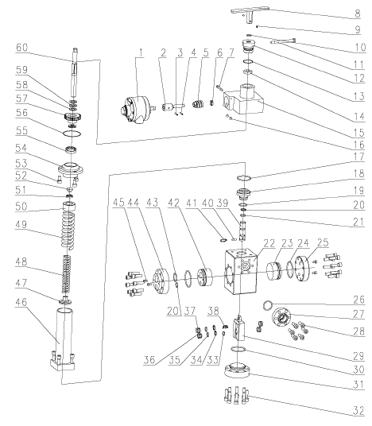
1 Pneumatic motor head 5126990461 1
2 Adaptor sleeve 9165100011 1
3 Elastic cylinder pin 4207010400 1 5×25
4 Elastic cylinder pin 4207010410 1 5×20
5 Worm screw 9165100009 1
6 Deep ball bearing 4301001370 1 21×12×5
7 Superposed valve screw 4201990060 1 M6×50
8 Handle body 9165101000 1
9 Hidden hex-conic end screw 4201030710 2 M6×6
10 O-ring 5303101120 1 15×2.65
11 Lock handle 9165100007 1
12 Lock cap 9165100008 1
13 O-ring 5303101110 1
14 Hexwasher 9165100006 1
15 Valve body 9165700022 1
16 Hidden hex-conic end screw 4201030360 2 M8×12
17 O-ring 5303001270 1 48.7×3.55
18 Guide sleeve 9161200010 1
19 O-ring 5303001130 1 30×2.65
20 Retaining ring 9161200011 1
21 O-ring 5303001010 2 17×2.65
22 valve body 9161100012 1
23 Plunger 9161100024 1
24 O-ring 5303001350 2 63×3.55
25 Flange 9161100023 1
26 O-ring 5303001180 1 33.5×3.55
27 Delivery flange 9161100025 1
28 Hidden hex screw 4201120240 6 M10×30
29 Seal box 9161200015 1
30 O-ring 5303001330 1 56×3.55
31 Lower plug 9161100018 1
32 Hidden hex screw 4201120250 28 M10×35
33 Wavy spring 9161100022 1
34 Retaining ring 9161100020 4
35 O-ring 5303001040 4 20×2.4
36 Oil drain sealing ring 9161100021 2
37 Relief sealing ring 9161200017 2
38 Spring 9161200016 1
39 Link rod 9161200009 1
40 Cylinder pin 4207010080 1 6×20
41 Elastic retaining ring for rod 4206021050 1 d0=22
42 Oil inducing plunger 9161200019 1
43 O-ring 5303001130 1 30×2.65
44 Oil inducing flange 9161100013 1
45 Hidden hex screw 4201120090 4 M6×25
46 Spring adjusting hood 9161101000 1
47 Spring pedestal 9161100008 1
48 Little spring 9161100007 1
49 Big spring 9161100006 1
50 Spring positioning disk 9161200005 1
51 Bearing 4301000060 1 51102
52 Bearing cover 9161200014 1
53 Hidden hex screw 4201120210 3 M10×20
54 Bearing pedestal 9165100001 1
55 Bearing 4301001350 1 48×38×13
56 O-ring 5303110060 1 69.57×1.78
57 Worm wheel 9165100002 1
58 Bearing shim 9165100003 4
59 Cylindrical roller bearing 4301001360 2 35×20×2
60 Core shaft 9165100004 1

