Keywords:34ZR6Y-L8A, Three-position four-way air valve
Beijing BPM,Beijing Petroleum Machinery Co.,Control System for Surface Mounted BOP Stacks, bop control unit, koomey unit, BPMF BOP CONTROL, accumulator unit, FKDQ1200-9,FKDQ1200-9B,FKDQ960-7,FKDQ640-7,FKQ1440-14,FKQ1200-9,FKQ1280-8,FKQ960-8,FKQ840-8,FKQ800-8,FKQ1280-7,FKQ1200-7,FKQ800-7D,FKQ800-7E,FKQ800-7F,FKQ800-8G,FKQ800-9H,FKQ640-7,FKQ800-6FFKQ720-6,FKQ640-6G,FKQ640-6,FKQ640-6M,FKQ640-6S,FKQ480-5,FKQ480-5C,FKQ480-5E,FKQ480-5B,FKQ480-5D,FKQ320-4B,FKQ3204E,FKQ320-4G,FKQ320-3,FKQ160-4W,FK250-4,FK240-4,FK160-4,FK100-4,FK240-3E,FKQ240-3D,FK240-3,FK125-3,FK125-3B,FK125-2D,FK125-2F,FK50-1

Product name:Three-position four-way air valve
Model:34ZR6Y-L8A
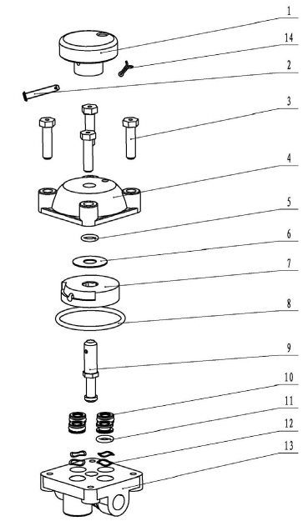
SN NAME ORDER NUMBER QUANTITY REMARKS
1 Knob 9163200009 1
2 Rod 4207030240 1 5×30
3 Bolt 9163200013 4
4 Upper valve body 9163100004 1
5 O-ring 5303000990 1 15×2.4
6 Spacer 9163100005 1
7 Gas-distribution valve core 9163201000 1
8 O-ring 5303001300 1 53×3.55
9 Mandrel 9163200011 1
10 Sealing ring 9163100003 4
11 O-ring 5303000940 4 9.5×2.65
12 Wave spring 9163100002 4
13 Lower valve body 9163100001 1
14 Unlock pin 4207030180 1 2×16

