Keywords:Y40-20,Relief valve
Beijing BPM,Beijing Petroleum Machinery Co.,Control System for Surface Mounted BOP Stacks, bop control unit, koomey unit, BPMF BOP CONTROL, accumulator unit, FKDQ1200-9,FKDQ1200-9B,FKDQ960-7,FKDQ640-7,FKQ1440-14,FKQ1200-9,FKQ1280-8,FKQ960-8,FKQ840-8,FKQ800-8,FKQ1280-7,FKQ1200-7,FKQ800-7D,FKQ800-7E,FKQ800-7F,FKQ800-8G,FKQ800-9H,FKQ640-7,FKQ800-6FFKQ720-6,FKQ640-6G,FKQ640-6,FKQ640-6M,FKQ640-6S,FKQ480-5,FKQ480-5C,FKQ480-5E,FKQ480-5B,FKQ480-5D,FKQ320-4B,FKQ3204E,FKQ320-4G,FKQ320-3,FKQ160-4W,FK250-4,FK240-4,FK160-4,FK100-4,FK240-3E,FKQ240-3D,FK240-3,FK125-3,FK125-3B,FK125-2D,FK125-2F,FK50-1

Product name:Relief valve
Model:Y40-20
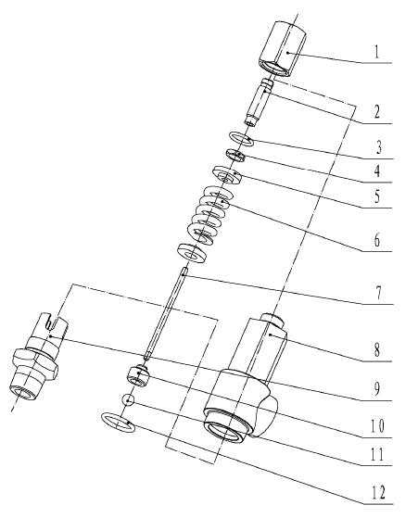
SN NAME ORDER NUMBER QUANTITY REMARKS
1 Sealing nut 9161600001 1
2 Adjusting screw 9161600002 1
3 O-ring 5303001030 1 19×2.65
4 Locking nut 9161600003 1
5 Spring beam 9161900004 2
6 Spring 9161900005 1
7 Valve rod 9161600006 1
8 Valve body 9161600007 1
9 Connection 9161600009 1
10 Ball seat 9161600008 1
11 Steel ball 4371010090 1 11
12 O-ring 5303001100 1 26.5×3.55

