Keywords:QKY21-25,Hydro-pneumatic pressure switch
Beijing BPM,Beijing Petroleum Machinery Co.,Control System for Surface Mounted BOP Stacks, bop control unit, koomey unit, BPMF BOP CONTROL, accumulator unit, FKDQ1200-9,FKDQ1200-9B,FKDQ960-7,FKDQ640-7,FKQ1440-14,FKQ1200-9,FKQ1280-8,FKQ960-8,FKQ840-8,FKQ800-8,FKQ1280-7,FKQ1200-7,FKQ800-7D,FKQ800-7E,FKQ800-7F,FKQ800-8G,FKQ800-9H,FKQ640-7,FKQ800-6FFKQ720-6,FKQ640-6G,FKQ640-6,FKQ640-6M,FKQ640-6S,FKQ480-5,FKQ480-5C,FKQ480-5E,FKQ480-5B,FKQ480-5D,FKQ320-4B,FKQ3204E,FKQ320-4G,FKQ320-3,FKQ160-4W,FK250-4,FK240-4,FK160-4,FK100-4,FK240-3E,FKQ240-3D,FK240-3,FK125-3,FK125-3B,FK125-2D,FK125-2F,FK50-1

Product name:Hydro-pneumatic pressure switch
Model:QKY21-25
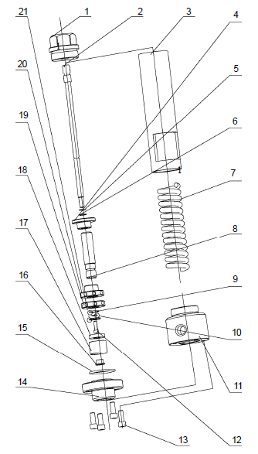
SN NAME ORDER NUMBER QUANTITY REMARKS
1 Valve seat 9161500016 1
2 Core rod 9161500012 1
3 Connecting sleeve 9161500011 1
4 Support sleeve 9161500014 1
5 O-ring 5303000960 1 11.2×2.65
6 Retaining ring 9161500015 1
7 Spring 9161500013 1
8 Support core housing 9161500010 1
9 O-ring 5303000040 1 10×1.8
10 O-ring 5303001010 1 17×2.65
11 Air connecting 9161500007 1
12 Hidden hex-cylinder screw 4201120070 1 M6×18
13 Hidden hex-cylinder screw 4201120220 4 M10×25
14 Connecting flange 9161500001 1
15 O-ring 5303001290 1 51.5×2.65
16 Press sleeve 9161500004 1
17 Sealing seat 9161500005 1
18 Sealing gasket 9161500017 1
19 Locking nut 9161500008 1
20 Back nut 9161500009 1
21 Washer 9161500006 1

